Collecting Audience Affinity Categories Through Google Analytics (January 15th to January 22nd, 2023)

Website/SEO Assignments

NAME: Tahiya Rahman

horizontal line

# About the Data

The purpose of the paper is to find out the types of affinity categories, bring the largest amount of new users and has the potentiality to grow more and appropriate to invest in future with NSTEM website. The data showed NSTEM’s potential affinity group where the users are most interested to spend more sessions and become the immediate lead target.

# Comparison of Data over the week 03 January, 2023

Jan 15th, 2023-Jan 22nd, 2023

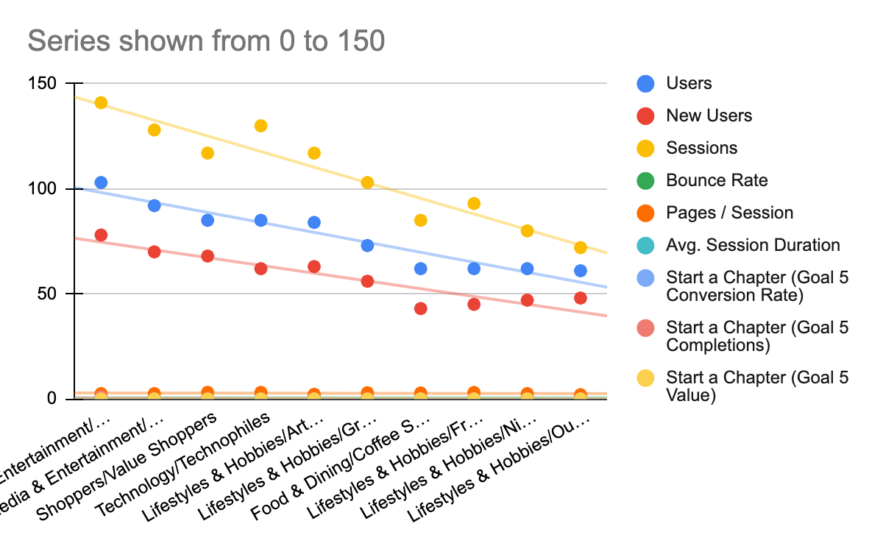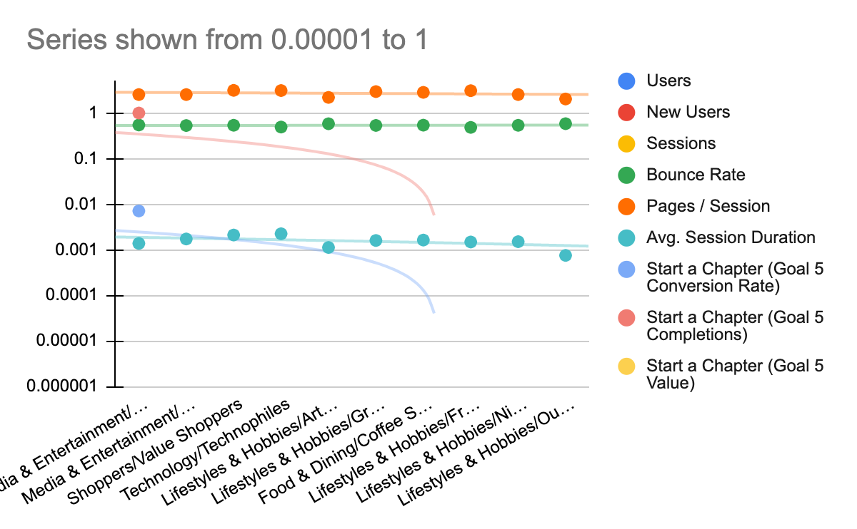

* As the data shown above, The data collected from Google analytics says that the most new users are coming from the **Media & Entertainment/Movie Lovers** and **Technology/Technophiles affinity groups.**
* Interesting fact, after calculating the rate for the new users generated from the existing users, discovered another potential scope, the **Shoppers/Value Shoppers Affinity group with a new user rate of 80%.**

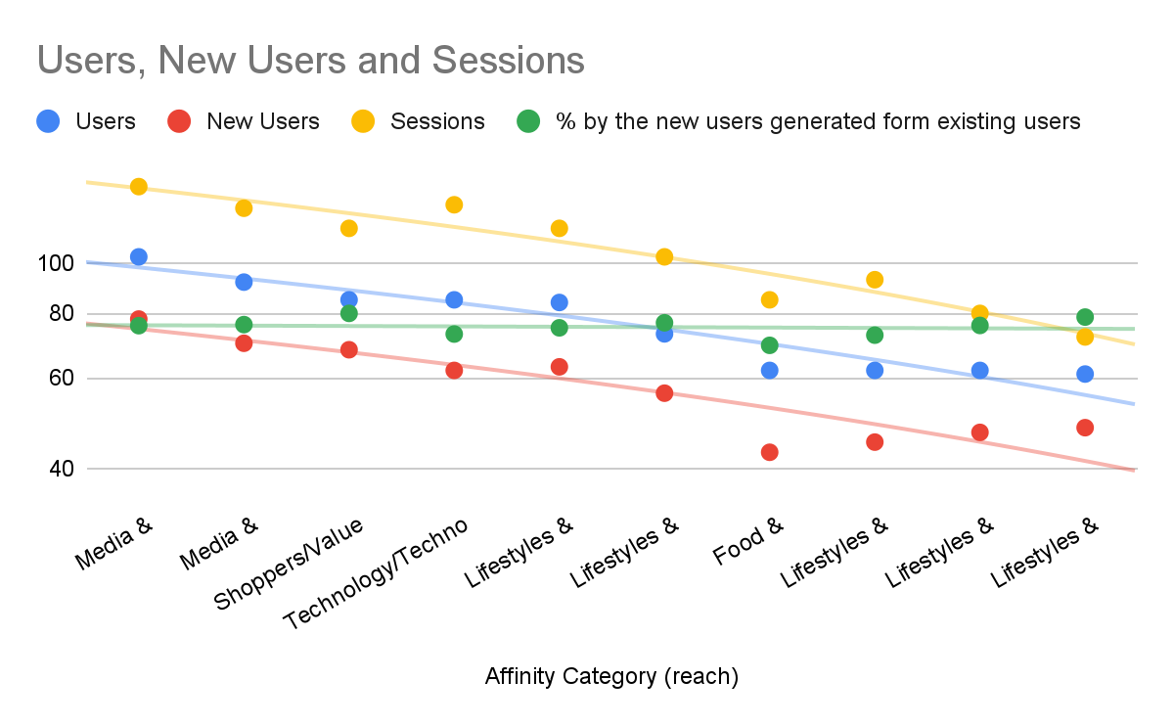 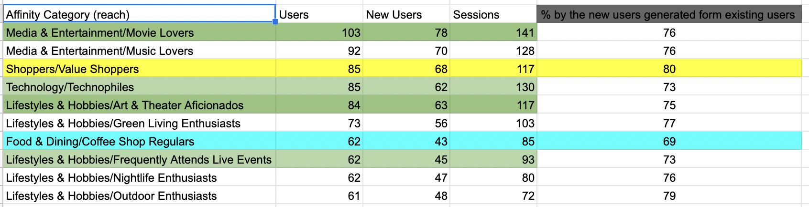

* Also, the data showed that the existing users have a decent number and are creating new users. It can be an interesting subject to investigate the reason how **Shoppers/Value Shoppers Affinity** groups hold the highest rate. **Food & Dining/Coffee Shop Regulars** showed the least interested group which seems to be credible data. Because the NSTEM website has no relation to provide services like food/dining/coffee shops.

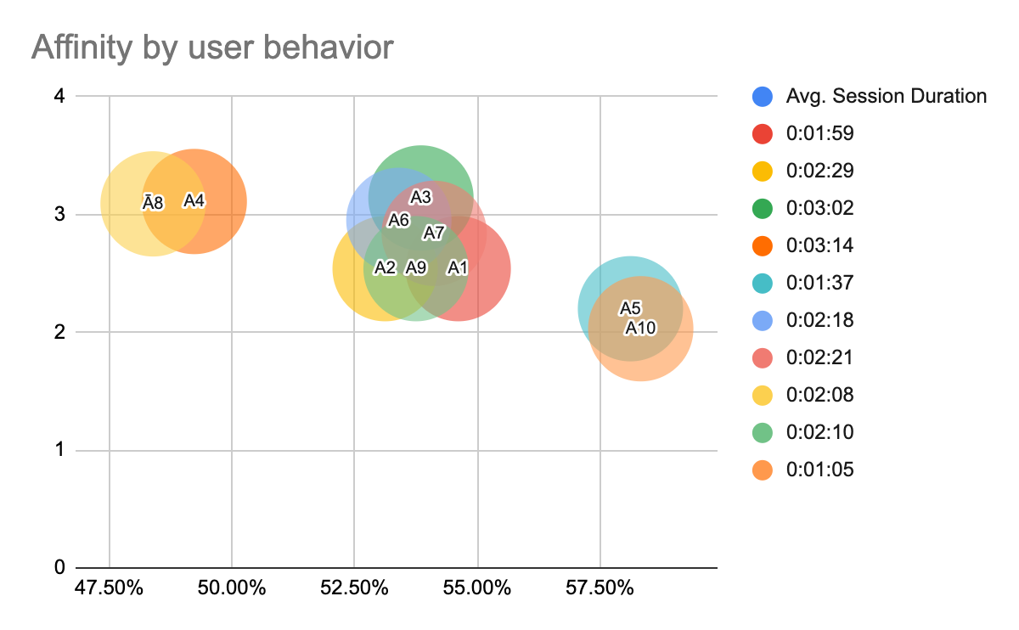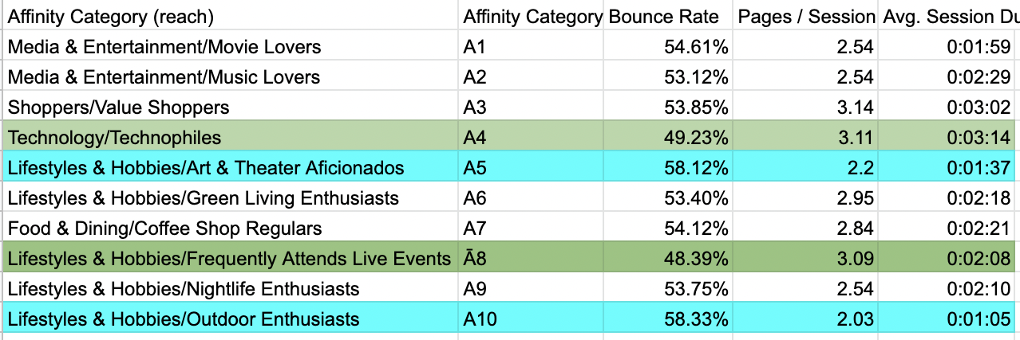

* **Technology/Technophiles** affinity group has the highest number for session and the lowest bounce rate with a decent pages/session for 03:11. Another new metric has been added as we observed from the dataset is **Lifestyles & Hobbies/Frequently Attends Live Events.** On the other hand, **Lifestyles & Hobbies/Art & Theater Aficionados, Lifestyles & Hobbies/Outdoor Enthusiasts** shows the least interested affinity group.

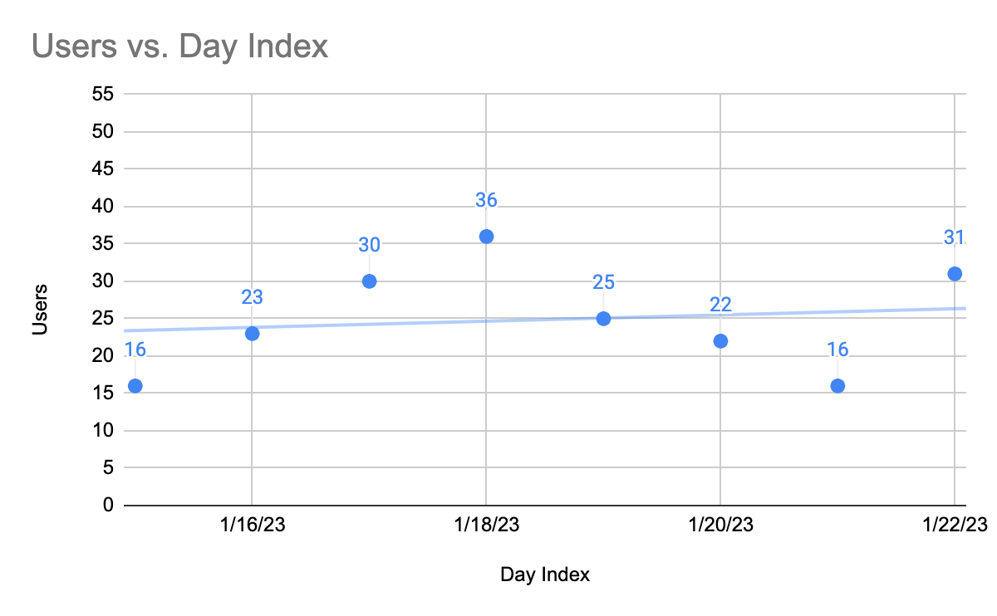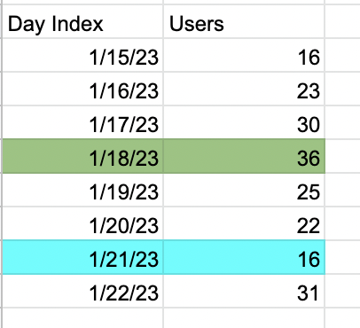

* From the Day index of January 2023, the data shown as the most users are generated on 18th January, Wednesday. And the least users were visited/gemetrated in 21st January, Saturday. The weekend days can always have a lower number than the other weekdays.

# What NSTEM Should Continue Doing

* NSTEM should continue to promote word of mouth for the new technology and the new opportunities within the chapter.
* NSTEM should identify the competitors and create a five forces model to create strategies to bring the new users.

# Ways to Improve the Website

* The affinity group, **Shoppers/Value Shoppers** showed decent data along with the **Media & Entertainment/Movie Lovers**, **Technology/Technophiles.** NSTEM can create more analytics and reports on the particular metric and filter to figure out how and where the analytics is getting the data and what kinda affinity group geologically, demographically for the investment.

# Data that Stands Out

From the analysis, the affinity categories are depicted as the reach in google analytics. Higher the reach, higher chance of people seeing/visiting the NSTEM website. By affinity groups we can understand the basis of the users and the demographics, interests. Mostly, Technology/Technophiles, Lifestyles & Hobbies/Frequently Attends Live Events, Media & Entertainment/Movie Lovers, Lifestyles & Hobbies/Art & Theater Aficionados and lastly Shoppers/Value Shoppers seem to be the interesting population for NSTEM.

# Conclusion

Google Sheets:

<https://docs.google.com/spreadsheets/d/1JWgMu5o4vWRaVaeEm_Xfn1PMdhpI1f4Xyk-btAdQMrs/edit?usp=sharing>

Google data Studio:

<https://lookerstudio.google.com/reporting/dd4c01d6-0502-4b0f-bf2f-90a335e0a61d>